Exercise 1: PL/SQL Control Structures
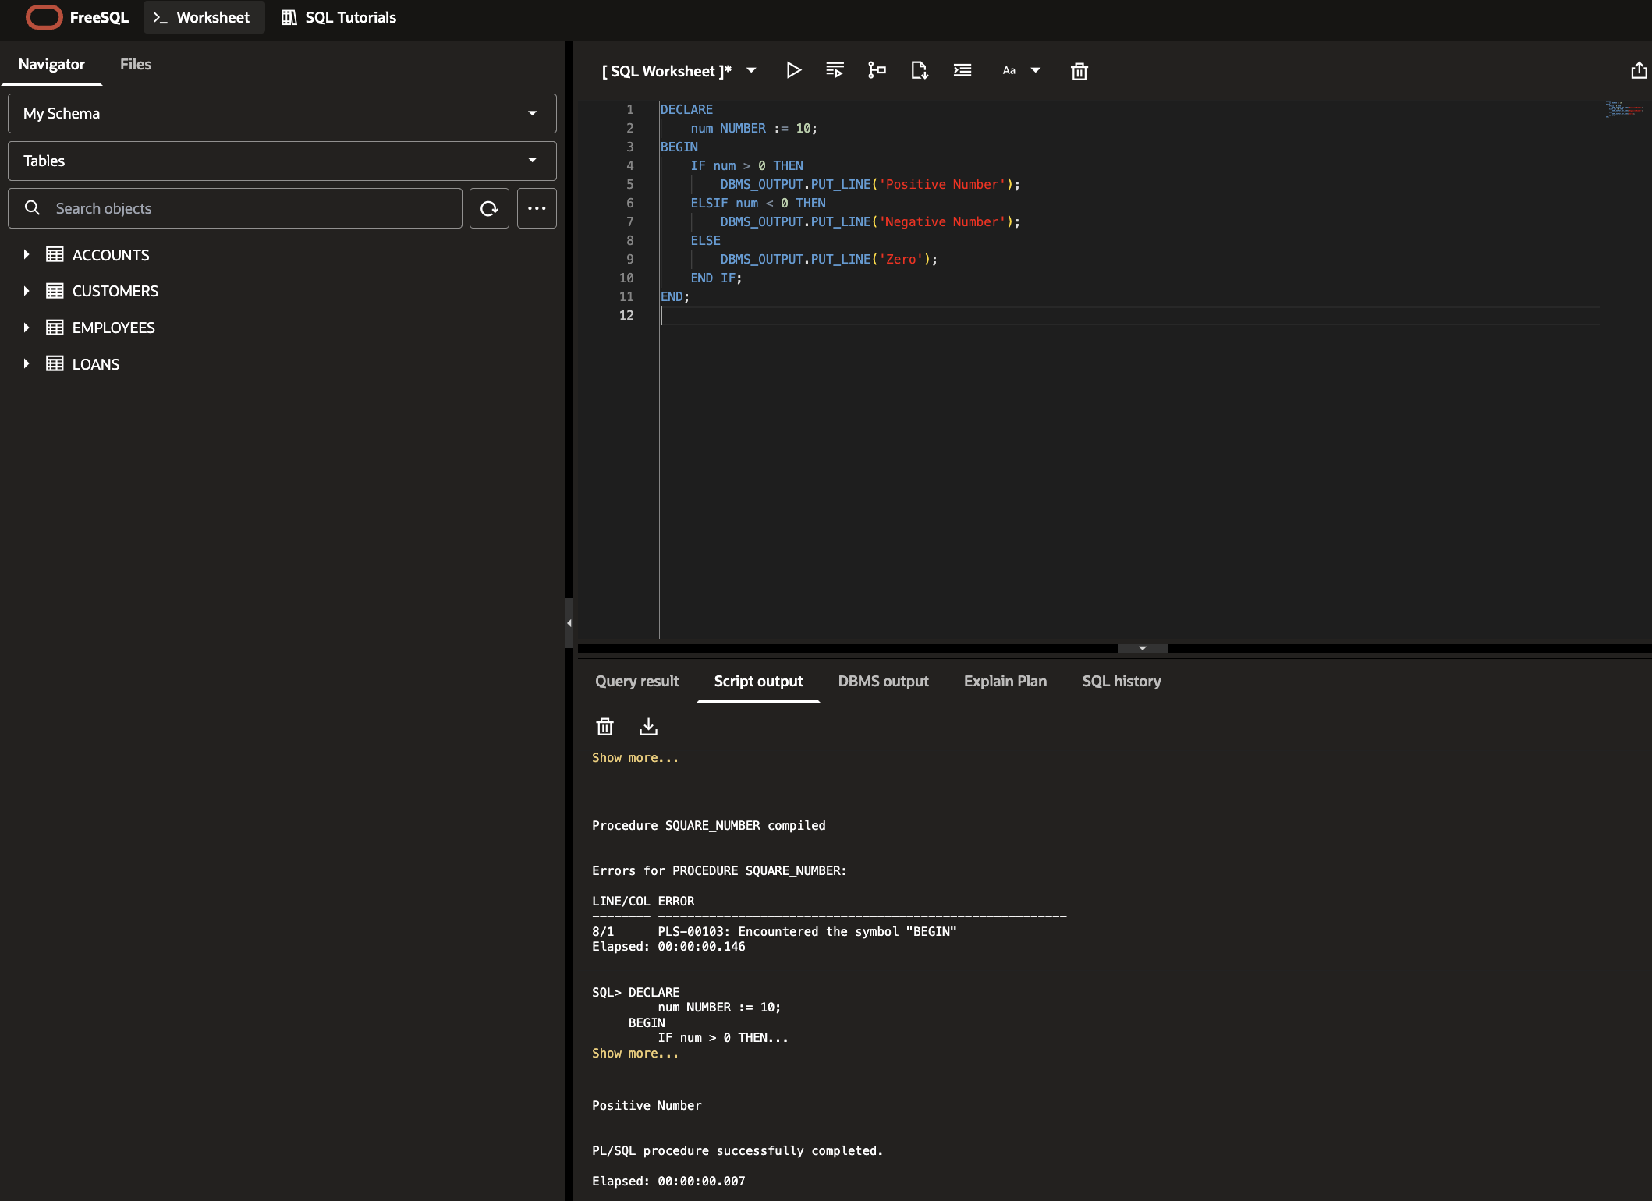
Exercise 2: Stored Procedure
